|  |  |  |  |  |
| --- | --- | --- | --- | --- |
| Google Merchandise Store | | [GO TO REPORT](https://analytics.google.com/analytics/web/?utm_source=pdfReportLink#/report/trafficsources-overview/a54516992w87479473p92324711/) | |  |
| 2 Test View | |  |
|  | |  |  |  |
| **Acquisition Overview** | |  |  |  |
| All Users |  | Oct 13, 2018 - Oct 19, 2018 | |  |
|  |  |  |  |
| 100.00% Users |  |  |  |  |
| **Primary Dimension:** | **Conversion:** |  |  |  |
| **Top Channels** | **eCommerce** |  |  |  |

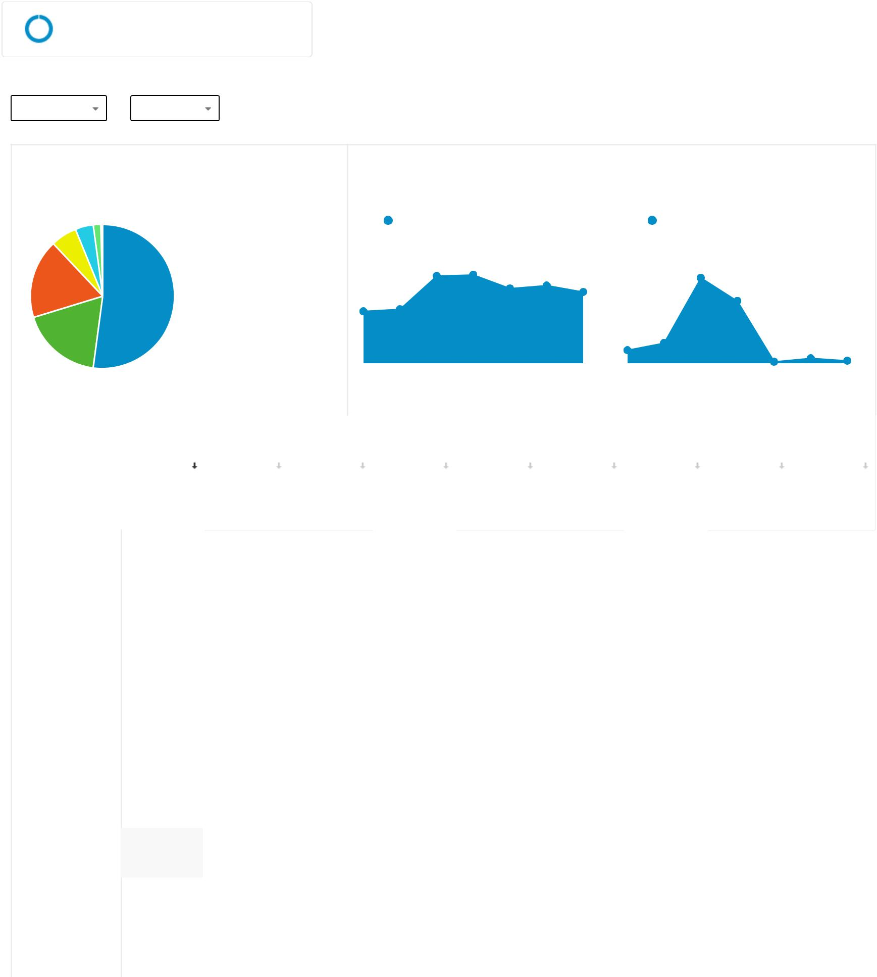

Top Channels

 Organic Search

 Referral

 Direct

 (Other)

17.7%

 Social

52.1%

 Display

 Other Paid Search

18.2%

 Branded Paid Search

 Generic Paid Search

|  |  |  |  |  |  |  |  |  |  |  |  |  |  |
| --- | --- | --- | --- | --- | --- | --- | --- | --- | --- | --- | --- | --- | --- |
| Users | |  |  |  |  |  |  | Conversions | | |  |  |  |
|  | Users |  |  |  |  |  |  |  | Ecommerce Conversion Rate | | | |  |
|  |  |  |  |  |  |  |  |  |  |  |  |  |  |
| 4,000 |  |  |  |  |  |  | 5.00% | |  |  |  |  |  |
|  |  |  |  |  |  |  |  |  |  |  |  |  |  |
| 2,000 |  |  |  |  |  |  | 2.50% | |  |  |  |  |  |
|  |  |  |  |  |  |  |  |  |  |  |  |  |  |
| … | … | … | … | … | … | |  | … | … | … | … | … | … |
|  |  |  |  |  |  |  |  |  |  |  |  |  |  |

|  |  |  |  |  |  |  |  |  |  |  |  |  |  |  |  |  |  |  |  |  |  |  |  |  |  |  |  |  |  |  |  |
| --- | --- | --- | --- | --- | --- | --- | --- | --- | --- | --- | --- | --- | --- | --- | --- | --- | --- | --- | --- | --- | --- | --- | --- | --- | --- | --- | --- | --- | --- | --- | --- |
|  |  |  | Acquisition | |  |  |  |  |  |  | Behavior |  |  |  |  |  |  |  |  |  |  |  | Conversions | |  |  |  |  |  |  |  |
|  |  |  |  |  |  |  |  |  |  |  |  |  |  |  |  |  |  |  |  |  |  |  |  |  |  |  |  |  |  |  |  |
|  |  |  | **Users** |  |  | **New Users** | | | **Sessions** | | **Bounce Rate** |  | **Pages /** | | | | |  | **Avg.** | | | | **Ecommerce** | | **Transactio…** | | | | **Revenue** | |  |
|  |  |  |  |  |  |  |  |  |  |  |  |  | **Session** | | | | |  | **Session** | | | | **Conversion** | |  |  |  |  |  |  |  |
|  |  |  |  |  |  |  |  |  |  |  |  |  |  |  |  |  |  |  | **Duration** | | | | **Rate** | |  |  |  |  |  |  |  |
|  |  |  |  |  |  |  |  |  |  |  |  |  |  |  |  |  |  |  |  |  |  |  |  |  |  |  |  |  |  |  |  |
|  |  |  |  | 15,041 |  | 12,641 | | | 19,313 | | 39.91% |  | 4.65 | | | |  | 00:03:00 | | | | | 1.27% |  | 246 | | | | $56,055.86 | |  |
|  | 1 | Organic Search |  | 8,231 |  |  |  |  |  |  | 47.24% |  |  |  |  |  |  |  |  |  |  |  | 0.68% |  |  |  |  |  |  |  |  |
|  |  |  |  |  |  |  |  |  |  |  |  |  |  |  |  |  |  |  |  |  |  |  |  |  |  |
|  |  |  |  |  |  |  |  |  |  |  |  |  |  |  |  |  |  |  |  |  |  |  |  |  |  |  |  |  |  |  |  |
| 2 | | Referral |  | 2,882 |  |  |  |  |  |  | 21.49% |  |  |  |  |  |  |  |  |  |  |  | 3.25% |  |  |  |  |  |  |  |  |
|  |  |  |  |  |  |  |  |  |  |  |  |  |  |  |  |  |  |  |  |  |  |  |  |  |  |
|  |  |  |  |  |  |  |  |  |  |  |  |  |  |  |  |  |  |  |  |  |  |  |  |  |  |  |  |  |  |  |  |
| 3 | | Direct |  | 2,800 |  |  |  |  |  |  | 32.46% |  |  |  |  |  |  |  |  |  |  |  | 1.22% |  |  |  |  |  |  |  |  |
|  |  |  |  |  |  |  |  |  |  |  |  |  |  |  |  |  |  |  |  |  |  |  |  |  |  |
|  |  |  |  |  |  |  |  |  |  |  |  |  |  |  |  |  |  |  |  |  |  |  |  |  |  |  |  |  |  |  |  |
| 4 | | (Other) |  | 925 |  |  |  |  |  |  | 43.43% |  |  |  |  |  |  |  |  |  |  |  | 0.47% |  |  |  |  |  |  |  |  |
|  |  |  |  |  |  |  |  |  |  |  |  |  |  |  |  |  |  |  |  |  |  |  |  |  |  |
|  |  |  |  |  |  |  |  |  |  |  |  |  |  |  |  |  |  |  |  |  |  |  |  |  |  |  |  |  |  |  |  |
| 5 | | Social |  | 626 |  |  |  |  |  |  | 60.69% |  |  |  |  |  |  |  |  |  |  |  | 0.00% |  |  |  |  |  |  |  |  |
|  |  |  |  |  |  |  |  |  |  |  |  |  |  |  |  |  |  |  |  |  |  |  |  |  |  |
|  |  |  |  |  |  |  |  |  |  |  |  |  |  |  |  |  |  |  |  |  |  |  |  |  |  |  |  |  |  |  |  |
| 6 | | Display |  | 274 |  |  |  |  |  |  | 71.35% |  |  |  |  |  |  |  |  |  |  |  | 0.58% |  |  |  |  |  |  |  |  |
|  |  |  |  |  |  |  |  |  |  |  |  |  |  |  |  |  |  |  |  |  |  |  |  |  |  |
|  |  |  |  |  |  |  |  |  |  |  |  |  |  |  |  |  |  |  |  |  |  |  |  |  |  |  |  |  |  |  |  |
| 7 | | Other Paid Search | | 47 |  |  |  |  |  |  | 38.60% |  |  |  |  |  |  |  |  |  |  |  | 0.00% |  |  |  |  |  |  |  |  |
|  |  |  |  |  |  |  |  |  |  |  |  |  |  |  |  |  |  |  |  |  |  |  |  |  |
|  |  |  |  |  |  |  |  |  |  |  |  |  |  |  |  |  |  |  |  |  |  |  |  |  |  |  |  |  |  |  |  |
| 8 | | Branded Paid | Se… | 13 |  |  |  |  |  |  | 27.78% |  |  |  |  |  |  |  |  |  |  |  | 0.00% |  |  |  |  |  |  |  |  |
|  |  |  |  |  |  |  |  |  |  |  |  |  |  |  |  |  |  |  |  |  |  |  |  |  |
|  |  |  |  |  |  |  |  |  |  |  |  |  |  |  |  |  |  |  |  |  |  |  |  |  |  |  |  |  |  |  |  |
| 9 | | Generic Paid | Sea… | 5 |  |  |  |  |  |  | 80.00% |  |  |  |  |  |  |  |  |  |  |  | 0.00% |  |  |  |  |  |  |  |  |
|  |  |  |  |  |  |  |  |  |  |  |  |  |  |  |  |  |  |  |  |  |  |  |  |  |
|  |  |  |  |  |  |  |  |  |  |  |  |  |  |  |  |  |  |  |  |  |  |  |  |  |  |  |  |  |  |  |  |

To see all 9 Channels click here.

* 2018 Google